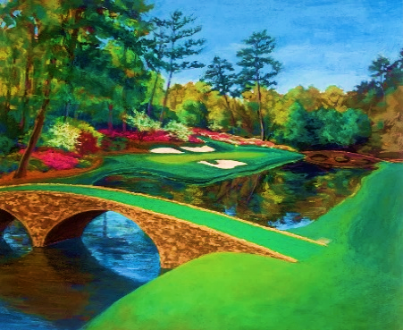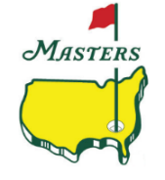 Masters Pool 2025

**29th Year**

April 10th – April 13th

trackphantom.com

**RULES:** Select required # of golfers per group; Golfer money won determines winners

**DUE:** Your selections and fee are due no later than Monday, April 7TH by 7PM CT

**HOW:** Send your completed board (or just selections) to dmvalento@outlook.com

|  |  |  |  |  |
| --- | --- | --- | --- | --- |
| **GROUP A - Select 2** | | | | |
| Brooks Koepka | Bryson DeChambeau | Collin Morikawa | Joaquin Niemann | Jon Rahm |
| Justin Thomas | Ludvig Aberg | Rory McIlroy | Scottie Scheffler | Xander Schauffele |

|  |  |  |  |  |
| --- | --- | --- | --- | --- |
| **GROUP B - Select 3** | | | | |
| Akshay Bhatia | Cameron Smith | Corey Conners | Dustin Johnson | Hideki Matsuyama |
| Jason Day | Jordan Spieth | Matt Fitzpatrick | Min Woo Lee | Patrick Cantlay |
| Patrick Reed | Robert MacIntyre | Russell Henley | Sahith Theegala | Sepp Straka |
| Shane Lowry | Tom Kim | Tommy Fleetwood | Tony Finau | Tyrrell Hatton |
| Viktor Hovland | Will Zalatoris | Wyndham Clark |  |  |

|  |  |  |  |  |
| --- | --- | --- | --- | --- |
| **GROUP C - Select 3** | | | | |
| Aaron Rai | Adam Scott | Billy Horschel | Brian Harman | Byeong Hun An |
| Cam Davis | Cameron Young | Daniel Berger | Davis Thompson | Denny McCarthy |
| Harris English | Justin Rose | Keegan Bradley | Laurie Canter | Maverick McNealy |
| Max Homa | Michael Kim | Phil Mickelson | Sam Burns | Sergio Garcia |
| Sungjae Im | Taylor Pendrith | Thomas Detry |  |  |

|  |  |  |  |  |
| --- | --- | --- | --- | --- |
| **GROUP D - Select 3** | | | | |
| Adam Schenk | Austin Eckroat | Chris Kirk | Christiaan Bezdenhout | Davis Riley |
| J.J. Spaun | J. T. Poston | Jhonattan Vegas | Joe Highsmith | Kevin Yu |
| Lucas Glover | Matt McCarty | Matthieu Pavon | Max Greyserman | Nick Dunlap |
| Nick Taylor | Nico Echavarria | Nicolai Hojgaard | Rasmus Hojgaard | Stephan Jaegar |
| Thriston Lawrence | Tom Hoge |  |  |  |

|  |  |  |  |  |
| --- | --- | --- | --- | --- |
| **GROUP E - Select 2** | | | | |
| Angel Cabrera | Bernhard Langer | Brian Campbell | Bubba Watson | Charl Schwartzel |
| Danny Willett | Fred Couples | Jose Maria Olazabal | Mike Weir | Patton Kizzire |
| Rafael Campos | Vijay Singh | Zach Johnson |  |  |

|  |  |  |  |  |
| --- | --- | --- | --- | --- |
| **GROUP F - Select 2 (Amateurs)** | | | | |
| Evan Beck | Hiroshi Tai | Josele Ballester | Justin Hastings | Noah Kent |

**Amateurs:** Amateurs do not earn money. So there will be money applied for the pool depending on their finish. The low am earns $50k whether they make the cut or not. If tied (both amateurs earn 50k). Any amateur that makes the cut gets additional 50k. Any amateur in the top 25 earns 100k. Any amateur in top 10 earns 250k. (Most money any amateur can make is 350k).

|  |  |  |
| --- | --- | --- |
| **NAME** | **PHONE** | **E-MAIL ADDRESS** |
|  |  |  |

**DID YOU SELECT 15 Golfers? --- CHECK YOUR BOARD ONCE MORE**