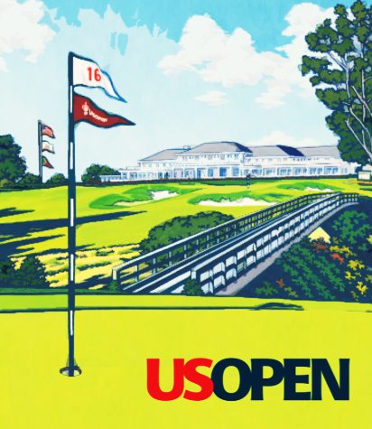
US OPEN POOL 2024

Rules: You win if you have the most total money earned by the 15 golfers you select

Due: Your selections for the US Open are due no later than Tuesday, June 11th 8 PM CT

How: Complete this sheet or type your picks in an email, send to dmvalento@outlook.com

GROUP A -- SELECT 3
Ludvig Åberg | Patrick Cantlay | Wyndham Clark | Bryson DeChambeau | Matt Fitzpatrick
Tommy Fleetwood | Max Homa | Viktor Hovland | Brooks Koepka | Hideki Matsuyama
Rory McIlroy | Collin Morikawa | Jon Rahm | Xander Schauffele | Scottie Scheffler
Cameron Smith | Jordan Spieth | Justin Thomas | Will Zalatoris

GROUP B -- SELECT 3
Byeong-Hun An | Daniel Berger | Akshay Bhatia | Keegan Bradley | Dean Burmester
Sam Burns | Corey Conners | Jason Day | Harris English | Tony Finau
Rickie Fowler | Brian Harman | Tyrrell Hatton | Russell Henley | Sungjae Im
Dustin Johnson | Tom Kim | Shane Lowry | Denny McCarthy | Alex Noren
Justin Rose | Sahith Theegala | Si Woo Kim | Min Woo Lee | Cameron Young

GROUP C -- SELECT 3
Christiaan Bezuidenhout | Cameron Davis | Thomas Detry | Nick Dunlap | Austin Eckroat
Ryan Fox | Emiliano Grillo | Adam Hadwin | Tom Hoge | Nicolai Højgaard
Billy Horschel | Mackenzie Hughes | Stephan Jaeger | Martin Kaymer | Chris Kirk
Kurt Kitayama | Adrian Meronk | Phil Mickelson | Taylor Moore | Matthieu Pavon
Taylor Pendrith | Victor Perez | J.T. Poston | Séamus Power | Aaron Rai
Webb Simpson | Sepp Straka | Nick Taylor | Erik van Rooyen | Gary Woodland

GROUP D -- SELECT 3
Sam Bennett | Eric Cole | Grant Forrest | Lucas Glover | Chesson Hadley
Harry Higgs | Beau Hossler | Mark Hubbard | Ryo Ishikawa | Takumi Kanaya
Riki Kawamoto | S.H. Kim | Jake Knapp | Matt Kuchar | Peter Malnati
Matteo Manassero | Tom McKibbin | Edoardo Molinari | Francesco Molinari | David Puig
Robert Rock | Adam Schenk | Jason Scrivener | Greyson Sigg | Adam Svensson
Brandon Thompson | Davis Thompson | Brendon Todd | Tiger Woods | Brandon Wu

GROUP E -- SELECT 3
Sam Bairstow | Zac Blair | Brian Campbell | Frankie Capan | Eugenio Chacarra
John Chin | Nicolas Echavarria | Max Greyserman | Jim Herman | Rico Hoey
Rikuya Hoshino | Casey Jarvis | Carter Jenkins | Sung Kang | Ben Kohles
Justin Lower | Willie Mack | Richard Mansell | Logan McAllister | Michael McGowan
Mac Meissner | Chris Naegel | Chris Petefish | Charles Reiter | Isaiah Salinda
Carson Schaake | Taisei Shimizu | Andrew Svoboda | Joey Vrzich | Tim Widing

Name | Phone | E-Mail

